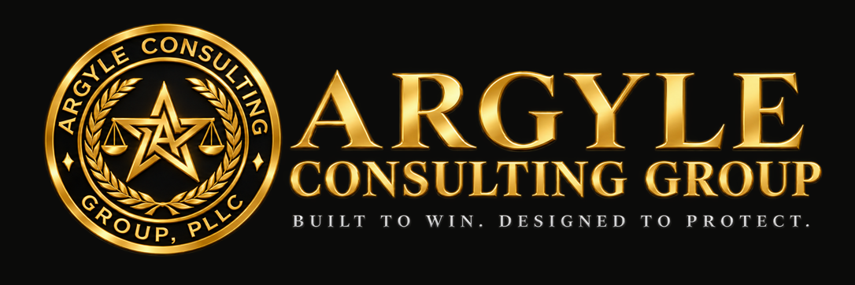

A CONTRACT REVIEW CHECKLIST

Subcontract Safety & Risk Clause Checklist
The safety terms that decide who pays after an injury on a Utah project.
For general contractors, subcontractors, and owners reviewing Utah construction subcontracts.

Devin Argyle, Attorney at Law
Argyle Consulting Group, PLLC | Bountiful, Utah
October 2026
General information only, not legal advice. Reading or using this guide does not create an attorney-client relationship. Facts and deadlines in a specific matter can change the right answer.

01 How to use this checklist
The safety terms in a subcontract decide who pays after an injury, not just who wears the hard hat. Use this checklist before signing or issuing any Utah construction subcontract, from either side of the table.
Rank | Meaning
Critical | Could void a protection or shift a major loss. Resolve before signature.
Important | Meaningful exposure. Negotiate.
Negotiable | Business preference.
Administrative | Clean-up.

02 Indemnity
In Utah, a construction indemnity clause cannot shift to the subcontractor liability caused by the general contractor’s own fault. Utah Code § 13-8-1 makes those provisions void and unenforceable as against public policy.
- The statute is broad. It covers promises to insure, hold harmless, indemnify, or defend, in or connected to a construction contract, and reaches bodily injury, property damage, and economic loss.
- Draft to fault. A clause written “to the extent caused by” the subcontractor’s negligence or breach is far more likely to hold up than “any and all claims arising out of the work.”
- Defense obligations count. A duty to defend the general contractor against its own negligence falls within the statute.
- Owner contracts are treated differently. Where an owner partly caused the damages, the statute apportions the owner’s share by proportional fault.
- Out-of-state forms. A national form governed by another state’s law may not reflect Utah’s rule. Check the governing-law clause.

Sample language · adapt to your contract and have counsel review
To the fullest extent permitted by law, including Utah Code § 13-8-1, Subcontractor shall indemnify and hold harmless Contractor from claims for bodily injury, property damage, or economic loss, but only to the extent caused by the negligent acts or omissions, or breach of this Subcontract, of Subcontractor or anyone for whose acts Subcontractor is liable.

03 Insurance and workers’ compensation
Insurance requirements do the work indemnity often can’t, but only if the endorsements actually exist.
- Additional insured. Require the general contractor (and owner, if required upstream) as additional insured on the subcontractor’s CGL policy, for ongoing and completed operations. Name the endorsement forms.
- Certificates are not coverage. A certificate of insurance is informational. Ask for the endorsements themselves.
- Primary and non-contributory. Without it, the general contractor’s own policy may be drawn in first.
- Waiver of subrogation on general liability, auto, and workers’ compensation, supported by endorsements.
- Limits that match the work, checked against the prime contract’s flow-down requirements.
- Workers’ compensation status. Under Utah Code § 34A-2-103(7), a business that retains supervision or control over work that is part of its trade can be treated as the employer of an uninsured subcontractor’s workers. Keep proof of each subcontractor’s coverage, or a valid waiver or compliance certification. Exclusive-remedy protection also depends on conditions that include adopting, posting, and enforcing a written workplace accident and injury reduction program.

Coordinate the insurance section with your broker. It is where legal drafting and coverage terms most often fail to match.

04 Safety responsibility
On a multi-employer site, more than one company can be cited for the same hazard, and the contract is one way OSHA decides which.
- Controlling-employer exposure. Under OSHA’s multi-employer citation policy (CPL 02-00-124), a contract right to require safety compliance and correct violations makes a general contractor a controlling employer. Broad control in actual practice can do the same, even if the contract disclaims it.
- What reasonable care looks like. Inspect at a reasonable frequency, correct hazards promptly, and enforce rules through graduated discipline with follow-up. Write the contract so the general contractor can do that, then do it.
- Subcontractor duties, stated plainly: compliance with applicable OSHA/UOSH standards for its own employees and work; a competent person where standards require one; its own written programs and training records.
- Site rules by reference. Incorporate the site-specific safety plan and orientation requirements, and require acknowledgment.
- Incident reporting to the general contractor fast enough to meet Utah’s 8-hour UOSH reporting deadline (R614-1-5): immediate notice of serious events, with a written report to follow.
- Stop-work and removal rights for imminent hazards and for personnel who repeatedly violate rules.
- Penalty pass-through. State whether citations caused by the subcontractor’s work are reimbursable, consistent with the indemnity limits above.
- Flow-down. Require the same terms in every sub-subcontract.

05 Review checklist
Work down the table. Resolve anything ranked Critical before signature.
Clause | What to check | Rank
Indemnity scope | Limited to the subcontractor’s fault (“to the extent caused by”); no indemnity or defense for the general contractor’s own negligence | Critical
Governing law | Utah law for Utah projects; national forms reviewed for conflicting indemnity terms | Critical
Workers’ comp proof | Current coverage, waiver, or compliance certification on file for every subcontractor | Critical
Additional insured | Endorsement forms named; ongoing and completed operations; primary and non-contributory | Critical
Incident notice | Immediate notice of serious events, fast enough to meet the 8-hour UOSH deadline | Important
Safety obligations | OSHA/UOSH compliance, competent persons, written programs, training records | Important
Control language | Matches how the site is actually run; supports inspection and graduated enforcement | Important
Waiver of subrogation | General liability, auto, and workers’ comp, with endorsements | Important
Stop-work and removal | Right to stop imminent hazards and remove repeat violators | Important
Penalty pass-through | Reimbursement of citations caused by subcontractor work, consistent with indemnity limits | Negotiable
Insurance limits | Match prime-contract flow-down requirements | Negotiable
Site plan by reference | Site-specific safety plan and orientation incorporated and acknowledged | Administrative
Flow-down | Same terms required in sub-subcontracts | Administrative

Sources
Utah Code § 13-8-1 · Utah Code § 34A-2-103 · OSHA Directive CPL 02-00-124 (Multi-Employer Citation Policy) · Utah Admin. Code R614-1-5. Current as of October 2026. Contract terms interact with each other and with policy language; have the full agreement reviewed before signing.
Argyle Consulting Group, PLLC · Bountiful, Utah · devin@argylepllc.com

