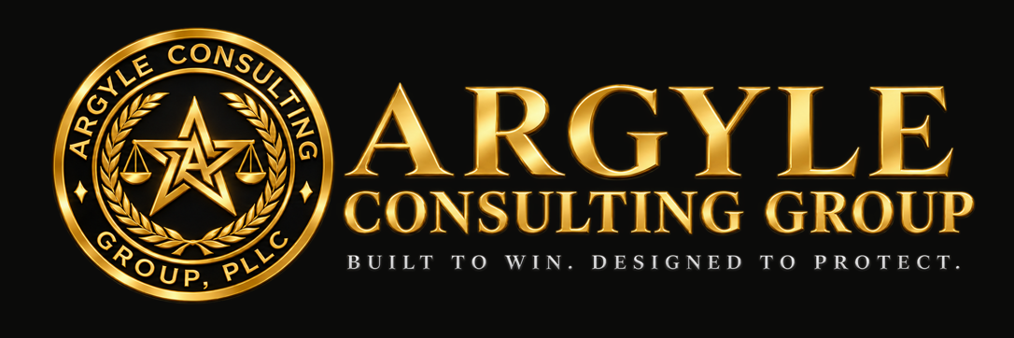

AN INCIDENT RESPONSE GUIDE

Protecting the Record After a Serious Incident
Reporting clocks, evidence, privilege, and reports that hold up later.
For owners, safety managers, and supervisors in the first days after a serious workplace incident.

Devin Argyle, Attorney at Law
Argyle Consulting Group, PLLC | Bountiful, Utah
October 2026
General information only, not legal advice. Reading or using this guide does not create an attorney-client relationship. Facts and deadlines in a specific matter can change the right answer.

01 The first hours
People first, then the scene, then the reporting clock. In Utah, that clock is 8 hours for most serious events.
- Care for the injured and protect everyone else from the same hazard. Nothing in this guide outranks that.
- Secure the scene. Stop work in the area. Leave equipment, materials, and conditions as they are unless changing them is needed to prevent further harm.
- Report on time. Federal OSHA: 8 hours for a fatality; 24 hours for an in-patient hospitalization, amputation, or loss of an eye (29 C.F.R. § 1904.39). Utah: notify UOSH within 8 hours of a fatality or any disabling, serious, or significant injury or occupational disease incident (R614-1-5). Report the facts known; don’t speculate about cause.
- Call counsel early, before written investigation work begins, if the event could lead to a citation, a lawsuit, or a dispute among contractors.
- Notify your insurers as your policies require. Late notice can jeopardize coverage.
- Notify the general contractor or owner if your contract requires it.

02 Preserve the evidence
Once a claim or citation is reasonably foreseeable, the company has a duty to preserve relevant evidence. Losing it can be worse than anything the evidence would have shown.
- Photograph and video the scene before anything moves: wide shots, close-ups, measurements, lighting, weather, and signage.
- Quarantine equipment and tools. Tag them out; don’t repair, discard, or return rentals until they are documented and counsel agrees.
- Pull electronic data before it overwrites: security footage, telematics and vehicle data, equipment logs, access-control records.
- Collect the paper: daily reports, JHAs and pre-task plans, inspection records, training and certification records, and the schedule for that day.
- Issue a written litigation hold to everyone likely to have relevant information, covering email, texts, and personal phones used for work.
- Log the chain of custody for every item: who collected it, when, and where it is kept.

03 Who investigates
Run two tracks: a prompt safety review that fixes the hazard, and, where exposure is significant, a separate investigation directed by counsel.
 | Safety review | Counsel-directed investigation
Purpose | Find and correct the hazard; prevent recurrence | Assess legal exposure; prepare for a citation, claim, or suit
Led by | Safety manager or operations | Attorney, or consultants retained by and reporting to the attorney
Output | Corrective actions with owners and dates | Privileged analysis and advice
Discoverable? | Generally yes | Protection is possible, but not guaranteed

- Communications between company counsel and employees made to obtain legal advice can be privileged (Upjohn Co. v. United States, 449 U.S. 383 (1981)). Counsel should tell employees that counsel represents the company, not them.
- Materials prepared in anticipation of litigation may be protected as work product.
- Privilege can be lost by sharing the material widely or mixing business and legal purposes. Mark privileged documents and keep distribution narrow.
- Never delay fixing a hazard to protect the investigation.

Remember
Facts are never privileged.
Photos, measurements, and what witnesses saw remain discoverable, and inspectors may interview the same witnesses. Privilege protects the advice, not the facts underneath it.

04 Witness statements and the report
Write what happened, not who is to blame. Conclusions written in the first days are often wrong, and they are quoted for years.

Statements
- Interview witnesses separately and soon, while memory is fresh.
- Ask open questions: what they saw, heard, and did, and where they were standing.
- Record their words. Don’t summarize them into your words, and don’t ask anyone to sign a statement they haven’t read.
- Never pressure, coach, or discourage a witness from speaking with OSHA or UOSH. Retaliation is prohibited.

The report
Write | Avoid
“The guardrail on the north edge was not in place at 10:15 a.m.” | “The crew ignored the fall protection rules.”
“Root cause under review” until it is established | “Operator error” or “careless” as a conclusion
Corrective action, owner, and due date | Recommendations no one is assigned to complete
The applicable standard, once confirmed | “This was an OSHA violation”

An open, untracked recommendation can later be offered as evidence the company knew about a hazard and did nothing. Track every corrective action to completion and record the date it closed.

05 Communications discipline
Every email, text, and post about the incident may later be read by a regulator, a jury, or an insurer.
- Keep internal messages to facts and logistics. Save analysis for conversations with counsel.
- Name one spokesperson for media, family, and owner inquiries.
- Ask crews not to post photos or comments about the incident. Don’t prohibit employees from discussing working conditions or talking to regulators.
- Express concern for the injured without assigning fault.

Closing checklist
☐ Injured cared for; hazard controlled
☐ Federal and UOSH reports made on time; time and contact recorded
☐ Counsel and insurers notified
☐ Scene photographed; equipment quarantined; electronic data pulled
☐ Litigation hold issued
☐ Witness statements taken separately, in their own words
☐ Two investigation tracks set up, with privileged material marked
☐ Report written as facts; corrective actions assigned and tracked
☐ Recordability decided and documented

Sources
29 C.F.R. § 1904.39 · Utah Admin. Code R614-1-5 · Upjohn Co. v. United States, 449 U.S. 383 (1981). Current as of October 2026. Privilege and preservation duties depend on the facts and the forum; get advice for a specific incident.
Argyle Consulting Group, PLLC · Bountiful, Utah · devin@argylepllc.com

