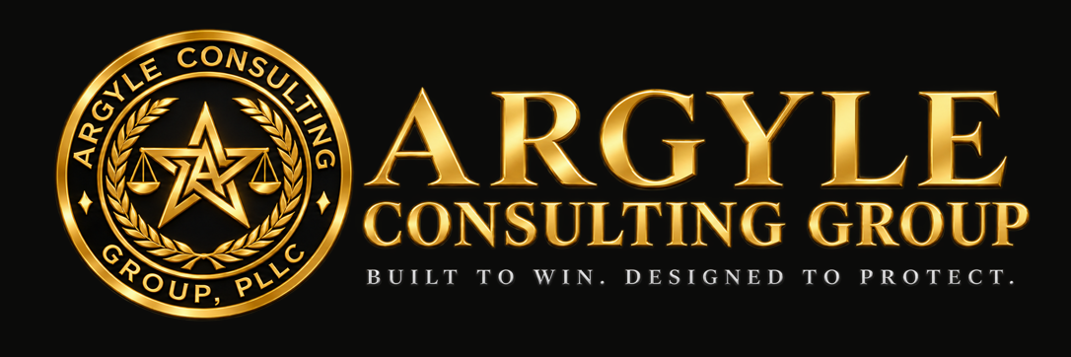

A PRACTICAL FIELD GUIDE

OSHA & UOSH Inspection Response Playbook
What to do from the knock on the door through the contest deadline.
For owners, superintendents, safety managers, and office staff. Covers federal OSHA and Utah’s state plan side by side.

Devin Argyle, Attorney at Law
Argyle Consulting Group, PLLC | Bountiful, Utah
October 2026
General information only, not legal advice. Reading or using this guide does not create an attorney-client relationship. Facts and deadlines in a specific matter can change the right answer.

01 Why the first hour matters
Most inspection outcomes are shaped before a citation is ever written. What the compliance officer sees, photographs, measures, and hears from employees and managers during the visit becomes the case file.
This playbook is for owners, superintendents, safety managers, and office staff who may be the first person an OSHA or Utah OSH (UOSH) compliance officer meets. It covers federal OSHA and Utah’s state plan; where they differ, both are noted.
The bottom line
Cooperative, organized, accurate.
The goal is not to obstruct. A cooperative, organized, and accurate response is the posture that protects the company best.

02 Before an inspector arrives
An inspection goes best when the company decided who does what before the knock on the door.
- Name a primary and a backup contact for each office and jobsite. Front-desk staff and superintendents should greet the inspector, ask them to wait briefly, and call that person.
- Decide who can consent to an inspection and who calls counsel. Write it down.
- Know where the records are: OSHA 300 Logs, 300A summaries and 301 reports for the past five years; written programs; training records; safety data sheets; equipment inspection logs. Injury and illness records must be produced within four business hours of a request (29 C.F.R. § 1904.40).
- Keep a response kit at each site: camera, notebook, measuring tape, and a copy of this playbook.
- Brief supervisors on employee interview rights and anti-retaliation rules. A supervisor’s careless comment can become evidence of employer knowledge.

03 When the inspector arrives
Verify, clarify the scope, and get your designated contact in the room before the walkaround starts.
- Check credentials. Ask for the compliance officer’s agency ID, whether federal OSHA or UOSH, and record the name and office.
- Ask why they are there: programmed inspection, employee complaint, referral, reported injury, or emphasis program. The reason usually defines the expected scope. If it is a complaint, ask for a copy.
- Ask for a brief wait while your designated contact arrives. A short, reasonable delay is normal; stalling is not.
- Decide on consent. Employers may insist on a warrant for a nonconsensual inspection (Marshall v. Barlow’s, Inc., 436 U.S. 307 (1978)). Most companies consent, often limited to the stated scope. Talk to counsel before refusing entry.
- Hold the opening conference. Confirm the scope, the areas to be visited, the documents wanted, and who will accompany the inspector. On a multi-employer site, notify the general contractor and affected subcontractors.
- Take notes from the start. Record times, names, and every statement and request.

04 The walkaround
Stay with the inspector the whole time and build your own record of everything they record.
- Accompany at all times and follow the same route. Don’t lead the inspector into areas outside the agreed scope.
- Shadow the evidence. Take the same photos and video from the same angle. Note every measurement. If they sample air or noise, ask what is being sampled and consider parallel sampling.
- Correct obvious hazards on the spot when it is safe to do so. Prompt correction shows good faith, but it does not erase a violation already observed.
- Answer accurately and briefly. Don’t guess, speculate, or volunteer opinions. “I don’t know; I’ll find out” is a complete answer.
- Watch what managers say. A supervisor’s knowledge of a hazard is generally imputed to the employer. Statements like “we’ve always done it this way” become evidence.
- Protect trade secrets. Identify confidential processes or information and ask that they be treated as confidential (29 C.F.R. § 1903.9).

Employee interviews
Inspectors may interview hourly employees privately. Don’t interfere, coach, or ask employees afterward what they said. Retaliation against an employee for participating is prohibited under Section 11(c) of the OSH Act and Utah’s parallel statute. Interviews of managers and supervisors are different: they speak for the company, and the company may have a representative or counsel present.

05 Document requests and the closing conference
Produce exactly what is requested, keep a copy of everything, and use the closing conference to listen.
- Ask for requests in writing, or confirm them by email.
- Log every document produced: what, when, and to whom. Keep an identical copy.
- Produce what exists. Never create, edit, or backdate a record in response to an inspection. Mark confidential material as confidential.
- At the closing conference, note each apparent violation, the standard cited, and the proposed abatement. Ask questions; don’t argue the merits there.
- Ask about next steps: expected timing of any citation and how to request an informal conference. Under federal law, a citation must issue within six months of the violation (29 U.S.C. § 658(c)).

06 After a citation arrives
The contest clock starts on receipt. If it runs out, the citation and penalty become final and cannot be reviewed.
Step | Federal OSHA | Utah (UOSH)
Contest deadline | 15 working days from receipt (29 U.S.C. § 659(a)) | 30 days from receipt, by notice to the Division of Adjudication (Utah Code § 34A-6-303)
If no contest is filed | Citation and penalty become a final order, not reviewable | Citation and proposed assessment become final
Informal conference | Request promptly; it does not extend the contest deadline | Ask UOSH; assume it does not extend the deadline
Posting the citation | At or near each violation for 3 working days or until abated, whichever is longer (29 C.F.R. § 1903.16) | Confirm the current UOSH posting rule
Abatement certification | Within 10 calendar days after each abatement date (29 C.F.R. § 1903.19) | Confirm the current UOSH requirement

Practical sequence
- Calendar the contest deadline the day the citation arrives. Count conservatively.
- Post the citation as required.
- Decide within the first week whether to request an informal conference, contest, or settle.
- Abate and document abatement for any item you won’t contest.
- Consider how each item could affect repeat-violation exposure, insurance, and bids that ask about safety history.

07 Quick-reference checklist
☐ Credentials checked; agency, name, and office recorded
☐ Reason for the inspection and its scope confirmed
☐ Designated contact present; counsel called if needed
☐ Consent decision made, and its scope noted
☐ General contractor and subcontractors notified (multi-employer site)
☐ Inspector accompanied for the entire walkaround
☐ Matching photos, measurements, and notes taken
☐ Every document produced is logged and copied
☐ Closing-conference items written down
☐ Contest deadline calendared the day the citation arrives

Reporting
If a serious event triggered the visit
Federal OSHA requires a report within 8 hours of a work-related fatality and within 24 hours of an in-patient hospitalization, amputation, or loss of an eye (29 C.F.R. § 1904.39). Utah requires employers to notify UOSH within 8 hours of a work-related fatality or any disabling, serious, or significant injury or occupational disease incident (Utah Admin. Code R614-1-5).

Sources
29 U.S.C. § 658(c) and § 659(a) · 29 C.F.R. §§ 1903.9, 1903.16, 1903.19, 1904.39, 1904.40 · Utah Code § 34A-6-303 · Utah Admin. Code R614-1-5 · Marshall v. Barlow’s, Inc., 436 U.S. 307 (1978). Current as of October 2026; confirm UOSH posting and abatement rules before relying on them.
Argyle Consulting Group, PLLC · Bountiful, Utah · devin@argylepllc.com

